**ALGORITHMS & COMPLEXITY**

**CS203.3**

**Dr. Rasika Ranaweera**

**Assignment II**

**Type:** Individual & Mandatory

**Duration:** 2 Hours (+ Homework)

**Lab Exercise (Algorithm Revision)**

**Important:**

* Objective is to understand, implement, and analyze familiar algorithms.
* Hand over your answer sheets (on top write your name, ID, course code) to an instructor.
* Save your programs under **home/cs203.3/** directory in your computer.
* Learn from others, read books, or Google but DO NOT COPY 1-to-1.

**Introduction:**

Sorting is about ordering objects. We can distinguish different types of sorting:

* Internal sorting: A small no of objects that can fit into the main memory.
* External sorting: A large no of objects that require external storage during the sort.
* Stable, oblivious, sort by address etc.

**Assignment:**

1. Write algorithms, pseudo-codes, and source codes (using any language you are comfortable) for following sorting algorithms and improve your programs.
2. Use illustrations to explain **selection** sort and **bucket** sort algorithms (like the following for heap sort algorithm).

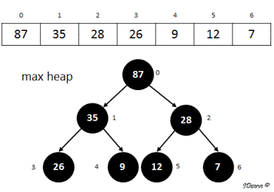

(source: https://www.ideserve.co.in/learn/heap-sort)

1. Write algorithms, pseudo-codes, and source code for **selection** sort and **bucket** sort.
2. Test your programs with [*20, 46, 22, 19, 6, 42, 14, 5, 48, 47, 17, 39, 51, 7, 2*] array.
3. Discuss the advantages, drawbacks, and limits of bucket sort.
4. Improve your program to support duplicates for the bucket sort algorithm.
5. Validate your program with [*20, 2, 46, 22, 19, 6, 22, 14, 5, 48, 47, 17, 39, 5, 51, 7, 2, 22*] array.